**R.V. COLLEGE OF ENGINEERING,**

**BANGALORE-560059**

**(Autonomous Institution Affiliated to VTU, Belgaum)**



Development and Application Of Concussion Sensors

MEMS Accelerometers

##### SELF STUDY REPORT

###### Submitted by **Vasishta Hd** USN No.1RV13IT058

**IV SEM**

**Dr. Prasanna Kumar ,Deepashree Devraj, Mr Kendagannaswamy, Mrs Sowmya , Dr CH Renumadhavi**

**Faculty**

**Department of Instrumentation Technology, R V College of Engineering**

Submitted to

**DEPARTMENT OF INSTRUMENTATION TECHNOLOGY**

**R.V. COLLEGE OF ENGINEERING, BANGALORE - 560059**

**(Autonomous Institution Affiliated to VTU, Belgaum)**

**CONTENTS**

|  |  |  |
| --- | --- | --- |
| **Serial No** | **Topic** | **Page No** |
| 1) | Introduction | 2 |
| 2) | Literature Survey | 3 |
| 3) | Motivation | 3 |
| 4) | Concussion Awareness | 4 |
| 5) | How the system works? | 5 |
| 6) | Accelerometer | 6 |
| 7) | Concussion Application | 7 |
| 8) | Concussion Sensor In Game | 8 |
| 9) | Specifications | 9 |
| 10) | Objectives | 10 |
| 11) | Conclusion | 10 |
| 12) | Referances | 11 |

**INTRODUCTION**

**Concussion**, from the [Latin](http://en.wikipedia.org/wiki/Latin) *concutere* ("to shake violently")[[1]](http://en.wikipedia.org/wiki/Concussion#cite_note-Pearce-1) or *concussus* ("action of striking together"),is the most common type of [traumatic brain injury](http://en.wikipedia.org/wiki/Traumatic_brain_injury). Frequently defined as a [head injury](http://en.wikipedia.org/wiki/Head_injury) with a temporary loss of [brain function](http://en.wikipedia.org/wiki/Brain_function), concussion causes a variety of physical, [cognitive](http://en.wikipedia.org/wiki/Cognition), and emotional symptoms, which may not be recognized if subtle.

Treatment involves monitoring as well as physical and cognitive rest (reduction of such activities as school work, playing video games and text messaging). Symptoms usually resolve within three weeks, though they may persist or complications may occur.

Those who have had one concussion seem more susceptible to another, especially if the new injury occurs before symptoms from the previous concussion have completely resolved.[[9]](http://en.wikipedia.org/wiki/Concussion#cite_note-Merck_Home_Health-9) There is also a negative progressive process in which smaller impacts cause the same symptom severity. Repeated concussions may increase the risk in later life for dementia, Parkinson's disease, and/or depression.

A variety of signs accompany concussion including somatic (such as headache), cognitive (such as feeling in a fog), emotional (such as emotional changeability), physical signs (such as loss of consciousness or amnesia), behavioral changes (such as irritability), cognitive impairment (such as slowed reaction times), and/or sleep disturbances. A 2010 *Pediatrics* review article focusing on children and adolescents noted that fewer than 10% of sports-related concussions had associated loss of consciousness.

Due to varying definitions and possible underreporting, the rate at which concussion occurs annually is not accurately known, but is estimated to be more than 6 per 1,000 people. Common causes include [sports injuries](http://en.wikipedia.org/wiki/Concussions_in_sport), bicycle accidents, car accidents, and falls, the latter two being the most frequent causes among adults. In addition to a blow to the head, concussion may be caused by [acceleration](http://en.wikipedia.org/wiki/Acceleration) forces without a direct impact, and on the battlefield, MTBI is a potential consequence of nearby explosions.

It is not known whether the brain in concussion is structurally damaged or whether there is mainly a loss of function with only [physiological](http://en.wikipedia.org/wiki/Physiology) changes. Cellular damage has reportedly been found in concussed brains, but it may have been due to [artifacts](http://en.wikipedia.org/wiki/X-ray_computed_tomography#Artifacts) from the studies.[[15]](http://en.wikipedia.org/wiki/Concussion#cite_note-Rees03-15) It is currently thought that structural and [neuropsychiatric](http://en.wikipedia.org/wiki/Neuropsychiatry) factors may both be responsible for the effects of concussion.

# Literature Survey:

* Bing K.F, Sharma A.C, Greneker E.F. ‘Detecting Concussion Impairment with Radar Using Gait Analysis Techniques’.
* Radar Conference (RADAR), 2011 IEEE. Publication Year: 2011 .
* Slobounov S, Sebastianelli W, Newell K.M.’ Incorporating Virtual Reality Graphics with Brain Imaging for Assessment of Sport-
* Related Concussions’. 2011 Annual International Conference of the IEEE. Page(s): 1383 – 1386. Publication Year: 2011.
* Suratkal D, ‘Processing Of Collision Data To Support Efficient Diagnosis of Concussion in Sports Athletes’ 2012 UKSim 14th
* International Conference on Digital Object Identifier, Publication Year: 2012 .
* Publication by Texas Instruments and University of Dallas in The Dallas Morning News, Feb 7th 2014.
* Means of EEG Signal Using Support Vector Machine ‘ Neural Systems and Rehabilitation Engineering, IEEE Transactions. Publication Year: 2008

# Motivation:

"A Compact Sensor System for Concussion Mitigation in Helmets – A Concept Prototype"

by Veena Divya K, Deepashree Devaraj, Rajasree PM and Anmol Oberoi -The Department of Instrumentation Technology, R.V. College of Engineering, Bangalore, India.

This paper presents a concept approach towards the detection of level of impacts to head, in a helmet and understands the severity of impact through signal processing technique. This System gives an indication though a LED and communicates to the emergency contacts fed to the GSM through wireless communication. Hence, the time needed for action is less as comparable to the existing methodology.

**Concussion awareness :**

Soldiers involved in blast events are often unaware they may have sustained a concussion and frequently continue on with their mission rather than seek medical attention. Several manufacturers have come up with sensor-based systems to better ensure that the blast-injured soldier gets the proper medical care. For example, a Diversified Technical Systems (DTS) product called HEADS comprises a data recorder and sensors inside the soldiers’ helmet. These devices remain dormant until the helmet is subjected to a blow.   
  
The HEADS sensors are designed to record only data exceeding a predetermined threshold – what might occur with a roadside bomb, for example. Once that threshold is reached, a visual LED display on the sensor is triggered, alerting the soldier of a potential head injury. The data within the sensor is easily downloaded via a USB device or summary data through a wireless connection. This is an extremely valuable solution for data download. Antennas can readily scan all available HEADS sensors in a Forward Operating Base and send the data to a computer, identifying any soldier who may have been involved in a blast or explosion, triggering the sensor.   
  
Impact-sensing military helmets have also been revamped for sports use, especially given the lack of accurate diagnosis of concussions, which are particularly dangerous when undiagnosed, often the case in contact sports such as football and ice hockey. In one of the numerous studies done on the impact of head trauma in contact sports¹, instrumented helmets contained six single axis microelectromechanical system (MEMS) accelerometers from [Analog Devices](http://www.digikey.com/us/en/techzone/sensors/supplier/Analog_Devices_Inc__505.html), along with data acquisition electronics, 128 Kbytes of memory capable of storing data for up to 100 impacts, and an RF transceiver.   
  
These experiments led Ottawa, Ontario, Canada startup Shockbox to the development by of a helmet sensor designed to detect head injuries and send alerts when medical attention is required. The flexible rubber device, which works with Android, iOS, and Blackberry smartphones, can fit inside any helmet with space between the padding the exterior; besides football, it can be used in such contact sports as hockey, lacrosse, skiing, snowboarding, mountain biking, and other extreme sports. 

**How the system works?**



These types of simple wearable devices are used by normal people while jogging, running and other applications where the users look at the display to notice the measured values of the sensors. The sensors are set to predetermined threshold limit so that other activities do not initiate the control chain.

If the device has the feature of wireless data transmitting capability, the data can be sent to a central station through a transceiver. The block diagram representation of a simple wearable wireless device is shown in Figure . Most of the data are stored, processed in the computer. Depending on the requirements, the results may be available through an access of a website from a remote place. The monitoring system may consists of many sensors are integrated .the data collected can be graphical displayed to make the diagnosis easier and more comfortable. The picture of the actual developed wearable physiological monitoring system is shown in figure.

The system consists of other sensors integrated as well as accelerometers to give the overall picture. All the measured physiological data are collected by a microcontroller to process and analyze .The controller transmits the data to a server via coordinators like zigbee, in between. The sever detects threat if any and initiates an automatic response system .The response system may include entities like doctors , hospitals, government , military etc.

Data may be stored for further research and future medical reference.

# Accelerometer:

The accelerometer is a built-in electronic component that measures tilt and motion. It is also capable of detecting rotation and motion gestures such as swinging or shaking.The most common use for it is to activate auto screen rotation on mobile devices when the user changes their orientation from portrait to landscape or vice-versa. Micro-Electro-Mechanical Systems, or MEMS, is a technology that in its most general form can be defined as miniaturized mechanical and electro-mechanical elements (i.e., devices and structures) that are made using the techniques of micro fabrication. The critical physical dimensions of MEMS devices can vary from well below one micron on the lower end of the dimensional spectrum, all the way to several milli meters.

Conceptually, an accelerometer behaves as a damped mass on a spring. When the accelerometer experiences an acceleration, the mass is displaced to the point that the spring is able to accelerate the mass at the same rate as the casing. The displacement is then measured to give the acceleration.

In commercial devices, [piezoelectric](http://en.wikipedia.org/wiki/Piezoelectricity), [piezoresistive](http://en.wikipedia.org/wiki/Piezoresistive_effect) and [capacitive](http://en.wikipedia.org/wiki/Capacitive_sensing) components are commonly used to convert the mechanical motion into an electrical signal. Piezoelectric accelerometers rely on piezoceramics (e.g. [lead zirconate titanate](http://en.wikipedia.org/wiki/Lead_zirconate_titanate)) or single crystals (e.g. [quartz](http://en.wikipedia.org/wiki/Quartz), [tourmaline](http://en.wikipedia.org/wiki/Tourmaline)). They are unmatched in terms of their upper frequency range, low packaged weight and high temperature range. Piezoresistive accelerometers are preferred in high shock applications. Capacitive accelerometers typically use a silicon micro-machined sensing element. Their performance is superior in the low frequency range and they can be operated in [servo](http://en.wikipedia.org/wiki/Servomechanism) mode to achieve high stability and linearity.

Modern accelerometers are often small *micro electro-mechanical systems* ([MEMS](http://en.wikipedia.org/wiki/Microelectromechanical_systems)), and are indeed the simplest MEMS devices possible, consisting of little more than a [cantilever beam](http://en.wikipedia.org/wiki/Cantilever) with a [proof mass](http://en.wikipedia.org/wiki/Proof_mass) (also known as *seismic mass*). Damping results from the residual gas sealed in the device. As long as the [Q-factor](http://en.wikipedia.org/wiki/Q_factor) is not too low, damping does not result in a lower sensitivity.

Under the influence of external accelerations the proof mass deflects from its neutral position. This deflection is measured in an analog or digital manner. Most commonly, the capacitance between a set of fixed beams and a set of beams attached to the proof mass is measured. This method is simple, reliable, and inexpensive.

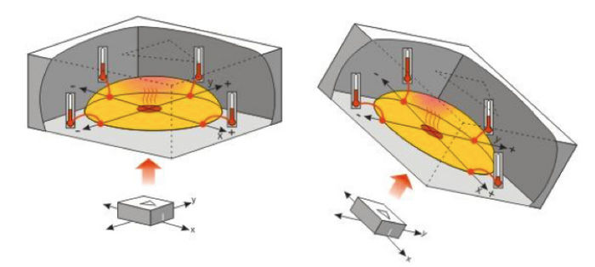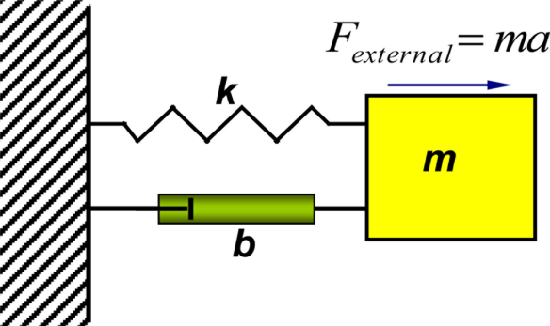

**Concussion application:**

Accelerometers are very commonly used in monitoring of human activity and basically are used to measure acceleration along a sensitive axis and over a particular range off frequencies. They can be used for many purposes such as detection of fall movement and analysis of body motion ,or a subject’s postural orientation as well the impact on the head . The impact determines the possible damage that could have occured.

**Concussion Sensor Used In Game Helmets:**

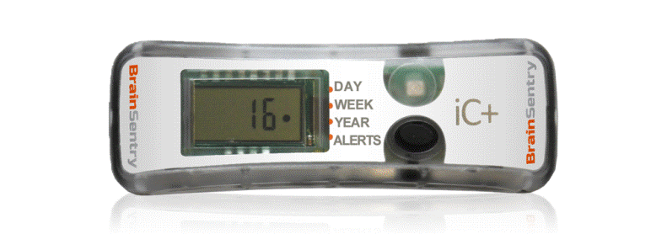

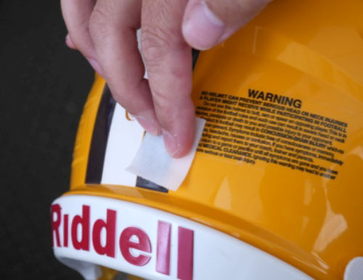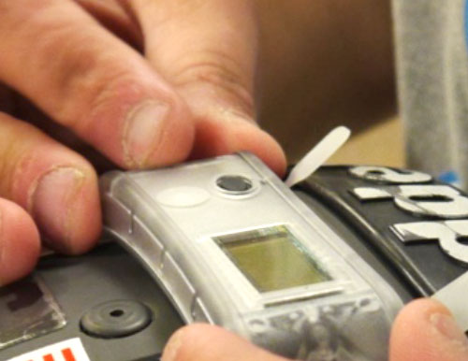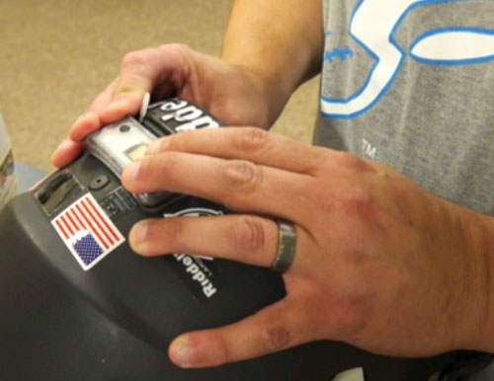

### CLEAN BACK OF HELMET

### ATTACH SENSOR

### ACTIVATE SENSOR

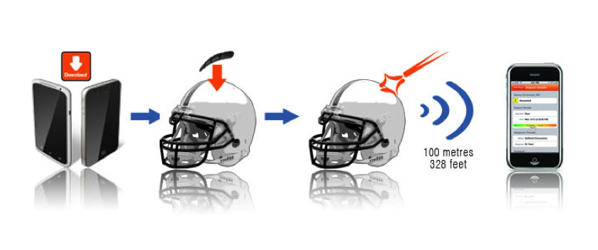

**Specifications:**

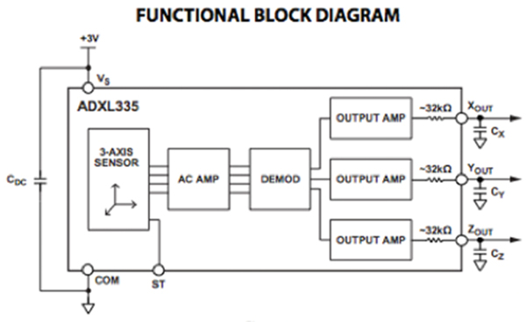

If the player has been hit too hard, the sensor will send a color-coded alert to a mobile device via Bluetooth; an orange alert will be sent for hits over 50 G, and a red alert is sent for hits over 90 G. A free app interprets the Shockbox data.   
  
A popular accelerometer for use in sports ad health devices is the [ADXL335](http://www.digikey.com/product-detail/en/ADXL335BCPZ-RL7/ADXL335BCPZ-RL7TR-ND/1995480) three-axis accelerometer from Analog Devices. The ADXL335 is a small, thin, low power, complete three-axis accelerometer with signal conditioned voltage outputs.

The product measures acceleration with a minimum full-scale range of ±3 g and can measure the static acceleration of gravity in tilt-sensing applications, as well as dynamic acceleration resulting from motion, shock, or vibration.

The user selects the bandwidth of the accelerometer to suit the application with a range of 0.5 to 1,600 Hz for the x and y-axes, and a range of 0.5 to 550 Hz for the z axis.

The ADXL335 is available in a small, low-profile, 4 × 4 × 1.45 mm, 16-lead, plastic lead-frame chip-scale package .

**Objectives:**

Our objectives for our next presentation would be to develop a concussion sensor is placed inside the helmet in contact with the head. Any force applied is detected by the sensor and then passed on the signal using the microcontroller . The signal received is analysed by processing later .

Our work will be mainly focussed on the development and application of right accelerometer to address the problem for better quality, cheap and effective detection.

**Conclusion:**

The current technology is highly implementable .Future work include by development of sensors of greater accuracy by use of newer technologies such as nanotechnology. By making the sensors more wearable, this technology can be implemented more easily in the army as well as common motorists. Other applications include construction workers, security personnel, mine workers ,etc. The system can also be designed to predict the exact effect of the impact .This can be by developed by using the data collected from the previous readings and developing the algorithms to analyse the same .

Other technologies can also be integrated such as power development using the athlete's motion .We can also optimize power consumption by selecting low power transmitting modules such as Zigbee and Bluetooth. By using bluetooth , the existing smart phones itself can be used. A cloud service which directly initiates the concerned Doctor and hospital can also be thought of.

**References:**

1. Pearce JM (2007). ["Observations on concussion. A review"](http://content.karger.com/produktedb/produkte.asp?typ=fulltext&file=000111872). *European Neurology***59** (3–4): 113–[doi](http://en.wikipedia.org/wiki/Digital_object_identifier):[10.1159/000111872](http://dx.doi.org/10.1159%2F000111872). [PMID](http://en.wikipedia.org/wiki/PubMed_Identifier) [18057896](http://www.ncbi.nlm.nih.gov/pubmed/18057896).
2. Brooks D, Hunt B (2006). ["Current concepts in concussion diagnosis and management in sports: A clinical review"](http://www.bcmj.org/node/851). *BC Medical Journal* **48** (9): 453–459.
3. National Center for Injury Prevention and Control (2003). ["Report to congress on mild traumatic brain injury in the United States: Steps to prevent a serious public health problem"](http://www.cdc.gov/ncipc/pub-res/mtbi/mtbireport.pdf) (PDF). Atlanta, GA: Centers for Disease Control and Prevention. Retrieved2008-01-19.
4. Petchprapai N, Winkelman C (2007). "Mild traumatic brain injury: determinants and subsequent quality of life. A review of the literature". *Journal of Neuroscience Nursing***39** (5): 260–72. [doi](http://en.wikipedia.org/wiki/Digital_object_identifier):[10.1097/01376517-200710000-00002](http://dx.doi.org/10.1097%2F01376517-200710000-00002). [PMID](http://en.wikipedia.org/wiki/PubMed_Identifier) [17966292](http://www.ncbi.nlm.nih.gov/pubmed/17966292).
5. Barth JT, Varney NR, Ruchinskas RA, Francis JP (1999). "Mild head injury: The new frontier in sports medicine". In Varney NR, Roberts RJ. [*The Evaluation and Treatment of Mild Traumatic Brain Injury*](http://books.google.com/?id=i4Tpx6wHvJ4C&pg=PA21&vq=concussion#PPA357,M1). Hillsdale, New Jersey: Lawrence Erlbaum Associates. pp. 85–6. [ISBN](http://en.wikipedia.org/wiki/International_Standard_Book_Number) [0-8058-2394-8](http://en.wikipedia.org/wiki/Special:BookSources/0-8058-2394-8). Retrieved 2008-03-06.
6. http://en.wikipedia.org/wiki/Concussion
7. https://www.sparkfun.com/datasheets/Components/SMD/adxl335.pdf
8. https://www.google.co.in/url?sa=t&rct=j&q=&esrc=s&source=web&cd=8&cad=rja&uact=8&sqi=2&ved=0CEgQFjAH&url=http%3A%2F%2Fwww.nlm.nih.gov%2Fmedlineplus%2Fconcussion.html&ei=dIjmVP3KJsfIuATCmIKIAg&usg=AFQjCNFIkNdTLM9HQKzUIqB9V3EeOQy0Mg
9. https://www.google.co.in/url?sa=t&rct=j&q=&esrc=s&source=web&cd=11&cad=rja&uact=8&sqi=2&ved=0CFsQFjAK&url=http%3A%2F%2Fkidshealth.org%2Fteen%2Fsafety%2Ffirst_aid%2Fconcussions.html&ei=dIjmVP3KJsfIuATCmIKIAg&usg=AFQjCNFs2lDMhzVecY14F1QAqPoxu17Faw